examples of cheap stainless steel coated wire ( down to 0.3mm dia, not thin enough I know, but it shows that ss wire doesn't need to be expensive by any means)
http://www.aliexpress.com/wholesale?catId=0&initiative_id=SB_20160102215700&SearchText=stainless+steel+tiger+tail
or coated stainless steel fishing line ( 10lb breaking strain seems to be about the thinnest, equates to 0.15mmdia or 0.008inch?) such as this one on amazon
http://www.amazon.com/Woodstock-Stainless-Steel-Fishing-Wire/dp/B0084ORP7K
seems there are plenty of ss 304 type coated fishing wire available.
What thickness is required for stans injector vic?
- Quote

- More…

brettly
- Senior Member
- Posts: 388

Re: Stanley Meyer Water Car Injector Drawings For The Water Powered Buggy!
« Reply #225, 3 months ago »
question regarding the injector quenching disc as per firepinto picture below which I've annotated.
does the water flow through the channels only, or does it flow across the whole structure ( blue arrow with red cross
through it)?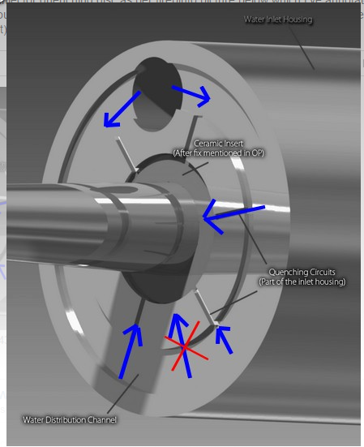
- Quote

- More…

quench.jpg - 35.03 kB, 437x547, viewed once.

Re: Stanley Meyer Water Car Injector Drawings For The Water Powered Buggy!
« Reply #226, 3 months ago »Last edited 3 months ago
something else i've noticed, there is a water jacket that extends inbetween the inner and outer stainless sections on the splitting zone end. This cylinder of water is 2.54mm in thickness,
what is the purpose of this cylinder of water? cooling? acoustic resonance? The injector could be build without this cylinder of water, so there must be some reason for it. The length of the water jacket of cylinderical shape is 2.285" ( 58mm). There is an 'o'ring at the end of the thread I assume to stop water escaping or am I miss reading the plans?
diagram below explains what I'm talking about:
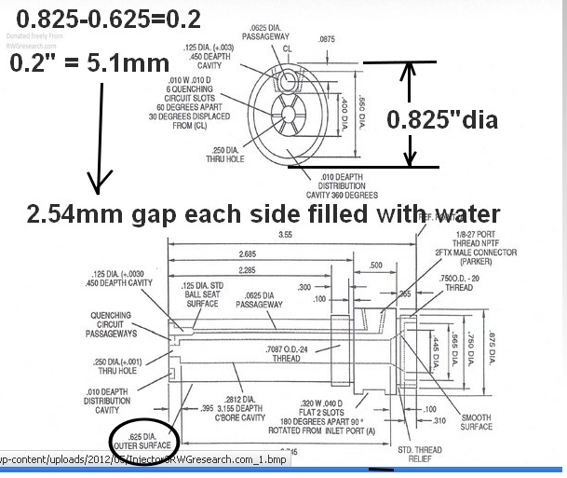
- 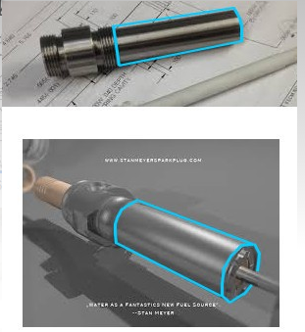Quote

- More…

water cavity explore.jpg - 79.57 kB, 606x518, viewed 7 times.

water cavity explore2.jpg - 24.22 kB, 301x343, viewed 3 times.

Re: Stanley Meyer Water Car Injector Drawings For The Water Powered Buggy!
« Reply #227, 3 months ago »Last edited 3 months ago
just to answer my previous question ( shown in previous diagram name 'quench') : if the water has to cross the quenching disc through the radial slots of the disc, it appears from dimensions that the water can cross any part of the quenching disc as there is a 0.01" gap.
see diagram below: red circles indicate lengths of the relevant parts 2.685-2.675 gives 0.01" gap.
Gap shown as blue line indicating a space for water. ( the water distribution cavity is also another 0.01" lower, which would mean a 0.02gap for water across the water distribution cavity.
( unless there is an error in the diagram dimensions). The o-ring would need to be such that the metal surfaces near the o-ring will be touching each other when the parts are screwed together.
I'm thinking there is an error on the dimensions and that the 0.01" gap shown as blue line is not meant to be there.
If the dimensions are correct it would mean there is a water jacket inbetween these parts as shown in my previous post.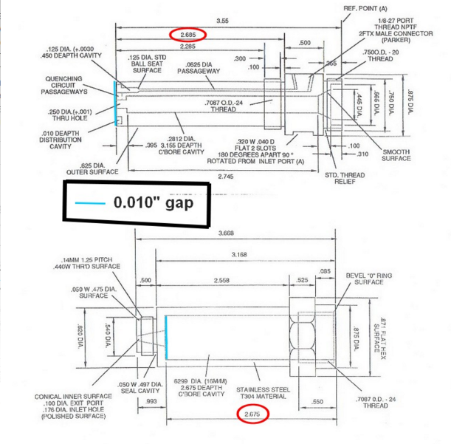
- Quote

- More…

water cavity explore6.jpg - 123.6 kB, 791x800, viewed 5 times.

Re: Stanley Meyer Water Car Injector Drawings For The Water Powered Buggy!
« Reply #228, 3 months ago »Last edited 3 months ago
i did show on a post some time ago, there was an error on stans diagram for the dimensions of another part,
so my guess is this is another error. Stan was not perfect, but it does make it difficult to know exactly how the injector is supposed to work. It will be difficult to know the purpose of making the outer jacket so long, whether its to keep the o-ring cool being further away from the engine,or to heat up the water using the injector heat ( it should get pretty hot), or whether the water jacket I've identified plays a role in the injector resonance or other function.
If the water jacket is supposed to be there, it might be for acoustic resonance?
It seems stan had matched the inner/outer tubes on the tube type wfc by using a slot to tune the outer pipe to the inner pipe, could it be this water jacket is playing a similar role?
There is an o-ring there for a reason, to stop water leaking out, so maybe the water jacket is supposed to be there.........I dont know!
- Quote

- More…

Re: Stanley Meyer Water Car Injector Drawings For The Water Powered Buggy!
« Reply #229, 3 months ago »Last edited 3 months ago
another pic showing where water might be in the injector, voltage zone, and another zone of unknown purpose. I'm just assuming that the water/gas mix in droplet form that goes into the injector, goes back to liquid form once in the distribution cavity.
- Quote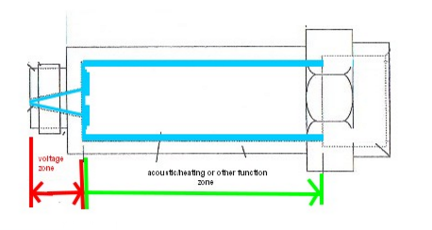

- More…

water cavity explore8.jpg - 21.47 kB, 469x249, viewed 3 times.

Re: Stanley Meyer Water Car Injector Drawings For The Water Powered Buggy!
« Reply #230, 3 months ago »
voltage zone water gap = 0.254mm
cylinder jacket water gap = 2.54mm
a factor of exactly 10.
from some calcs ( in my research information sharing thread)
292khz gives concentric acoustic resonant maxima in voltage zone ( 1/2 wavelength maxima at electrode surfaces),
Since the water jacket width is 2.54mm, it would mean you would fit 10maxima in that zone at same frequency, Perhaps no coincidence water jacket zone is exactly 10times as wide as voltage zone water gap width. It would mean that jacket of water also has standing waves concentric in nature ( could they act a bit like a drum or other resonator) amplifying the voltage zone acoustic resonance.........who knows!!??
I'm guessing here, perhaps the longitudonal length of the voltage zone to the water jacket, is also some integer value, so that resonance is also occuring with longitudonal waves in voltage zone, but also in the water jacket zone.
The zone where the two water zones interact acoustically, would be where the quenching disc is located........just guessing..some interaction going on there also.
0.254mm gap above the quenching disc also suggests acoustic resonance for that thin sheet of water which goes over quenching disc.
- Quote

- More…

Re: Stanley Meyer Water Car Injector Drawings For The Water Powered Buggy!
« Reply #231, 3 months ago »
just looking more closely at stans dimesions for the injector.
I've used his drawing and taken off irrelevant dimensions.
Below shows the length of the water jacket, using stans dimensions.
It is 2.125" length diagram below.
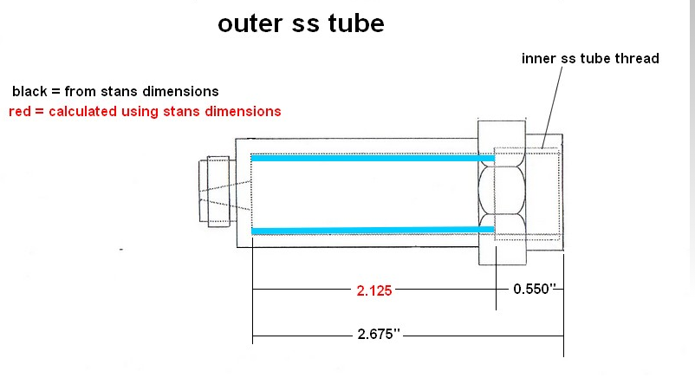
- Quote

- More…

water cavity explore9.jpg - 38.97 kB, 800x437, viewed 3 times.

Re: Stanley Meyer Water Car Injector Drawings For The Water Powered Buggy!
« Reply #232, 3 months ago »Last edited 3 months ago
compare with dimensions stan gives for the inner ss tube ( water inlet housing):
there appears to be a discrepency in dimensions. I previously showed a 0.01" gap at the end of the quenching disc, even not taking that into account he has given two different dimensions for the
placement of the thread on the inner ss tube ( which would give the longitudonal wavelength of the water jacket bewteen the inner/outer ss tubes).
he gives 2.285" for that length in the inner ss tube ( water inlet housing): see pic below
but he gives 2.125" for the outer ss tube ( plug housing)( picture above in previous post).
Thats a difference of 0.16" for what should represent the same dimension.
If you take into account the 0.01" gap I mentioned earlier, the dimensions are still not same on both diagrams.......so there is some error there......how to decipher the plug then becomes quite an issue. I realise some people have already had injector plugs made at great expense, how did they overcome these errors in stans drawings?
I'm not sure how you overcome these dimensional errors when trying to replicate the injector,
it might prove difficult to get it to work unless exact dimensions are known. Especially since the gaps involved can be as small as 0.01", and there appears an error on the scale of 0.16",
its going to be quite a task.
( hope some people will check my calculations also)
- Quote
- 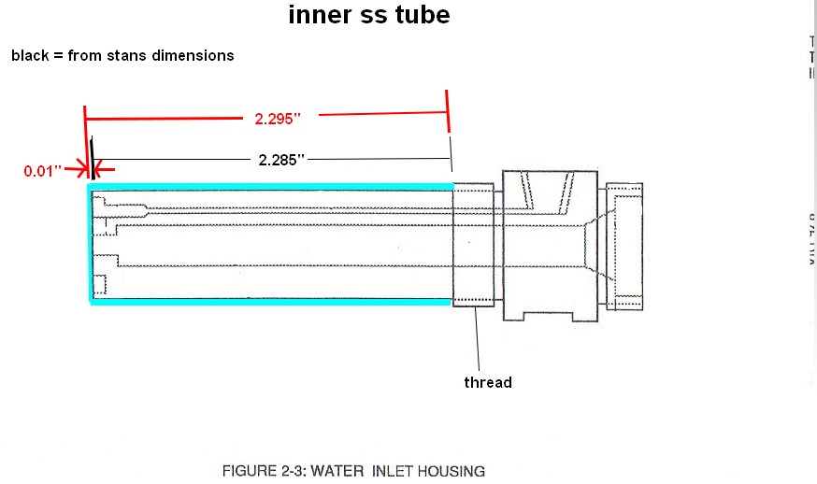More…

water cavity explore10.jpg - 51.74 kB, 880x526, viewed 3 times.

Re: Stanley Meyer Water Car Injector Drawings For The Water Powered Buggy!
« Reply #233, 3 months ago »Last edited 3 months ago
I haven't been looking for dimensional errors, just trying to work out some numbers for acoustic resonance, and trying to nut out how the injector works. But it seems there are alot of errors in the dimensions from stans estate injector drawings......damn.
I think I would assume that the quenching disc sits hard against the outer ss housing ( plug housing), so that water is forced through the small 0.01" slots ( perhaps the method to force droplets to coalesce for the voltage zone), that the water jacket space plays no role in the device,
and the long length of the outer ss housing, is to keep the rubber o-ring somewhat cooler, rather than having it very close to the engine ( near the voltage zone end). Where heat might damage it over time.
Very frustrating though to find dimensions are not 100% spot on.
- Quote

- More…

firepinto
- Global Moderator
- Posts: 1,404

Re: Stanley Meyer Water Car Injector Drawings For The Water Powered Buggy!
« Reply #234, 3 months ago »
I think the people that built injectors found problems with dimensions too, and just built it by what they thought made sense. We have to take into consideration that these are just patent drawings and not drawings that a machinist should use for production. From a drafting standpoint, there are a lot more problems with the drawing than just wrong dimensions. There are a lot of superfluous dimensions, which means things have double dimensions that will conflict each other tolerance wise. There is also no datum points to measure the dimensions from. All this has to do with tolerance stacking. Dimension numbers on paper don't mean anything if it isn't physically possible to machine the part with in tolerances. The way it is dimensioned now(not counting bad dimensions), if you took it to a machinist he could machine it with wrong dimensions and get away with it. Checking the part with a caliper would be done just like the dimensions are shown. That leaves a lot of room for error (tolerance stack).
Drawing models in 3D is one thing, but producing a drawing that puts it into production is another. A drawing is a legal document, it has to be dimensioned so that it can only be interpreted one way. Or someone is going to lose money.
- Quote

- More…
Woe to those who call evil good and good evil, who put darkness for light and light for darkness, who put bitter for sweet and sweet for bitter. Woe to those who are wise in their own eyes and clever in their own sight.
Isaiah 5:20-21
http://twitter.com/firepinto www.firepinto.com

brettly
- Senior Member
- Posts: 388

Re: Stanley Meyer Water Car Injector Drawings For The Water Powered Buggy!
« Reply #235, 3 months ago »
thanks for feedback, I assume no one has an original to measure up?
- Quote

- More…

Re: Stanley Meyer Water Car Injector Drawings For The Water Powered Buggy!
« Reply #236, 3 months ago »
from stans dimensions ( and pythagoras theorem) length of the inner injector is 0.9959" along the slope. So close enough to one inch, using 2.125 ( 2 1/8") as the length of water jacket between ss tubes ( 2.54mm gap). Gives ratio of 1:2.125.....if acoustic resonance along the length is playing any role in voltage zone and water jacket combined, thats the ratio ( using one set of dimensions).
Lets say voltage zone is open at one end ( quenching disc at other end), and water jacket is open one end ( quenching disc) then not sure if I can make sense of those dimensions when looking at acoustic resonance, perhaps water jacket is considered closed at one end, and the voltage zone considered open both ends, might be able to make some sense of that ration in that case.

